**Assignment 1:**

1. **Discuss your initial thoughts in detail on how you will design this application? (2 points)**
   1. Login:
      1. login/ Welcome page
      2. Two field username and password/ login-forgot password/New-user registration
   2. Registration page where it has a field for the customer to fill in about themselves, including first name, last name, set a new password, address.
   3. Redirected to the main dashboard where the user is required to fill the fuel quote form.
   4. Fuel Quote Form: After the selection of the nearest gas station (with respect to the client’s location), the user enters the number of gallons. The field for fuel rate is automatically filled with respect to the user choice. A tab “Calculate the total cost” then calculates and prints the total cost of the fuel to the user.
   5. A tab on the top left corner to allow the user to view Fuel Quote History
   6. On the top right a profile pic button that will have to drop down list to choose between changing account setting, logout- report an issue
2. **Discuss what development methodology you will use and why? (2 points)**

Agile Methodology allows us to develop a software collaboratively as we discover the requirements. As a result, the software is developed relatively quickly, with less time spent on design and analysis.

1. **Provide a high level design / architecture of your solution that you are proposing? (6 points)**

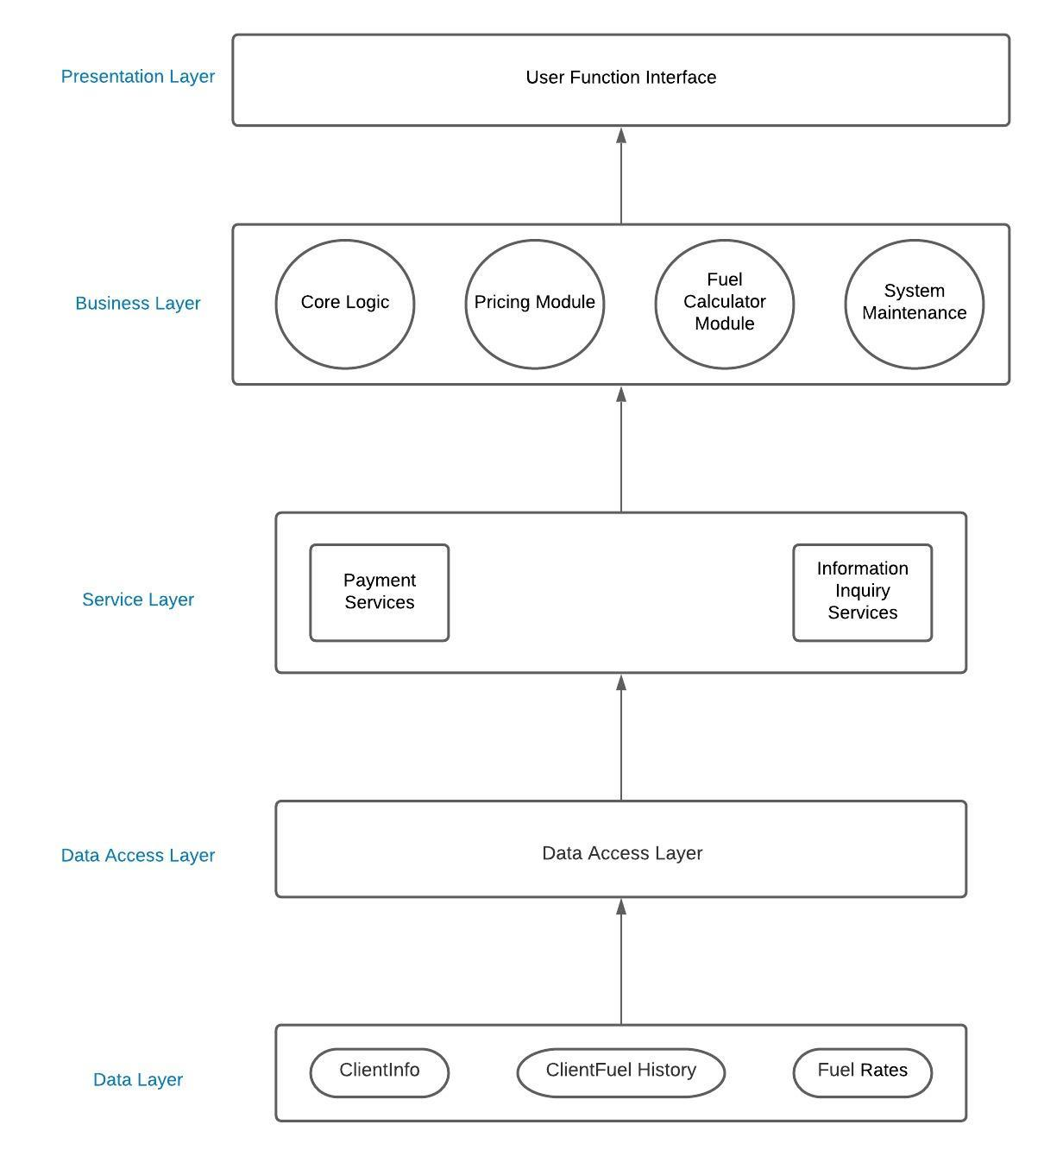

**Github Links:**

[**https://github.com/SSD21/Software-design**](https://github.com/SSD21/Software-design) **Samita Damani**